* Past Project Experience
* **\*Spring boot JPA  
  What is Spring Boot JPA?**

Spring Boot JPA is a part of the Spring Data project, which aims to simplify data access and manipulation in Java applications. It provides a set of tools and abstractions to work with relational databases using the Java Persistence API (JPA).

**Key Concepts**

**JPA (Java Persistence API)**:

JPA is a specification for accessing, persisting, and managing data between Java objects and relational databases.

It provides a standard way to map Java objects to database tables and vice versa.

**Spring Data JPA**:

Spring Data JPA is a part of the larger Spring Data family, which provides easy integration with JPA.

It simplifies the implementation of data access layers by reducing boilerplate code.

**Core Components**

**Entities**:

Entities are Java classes that map to database tables.

Each entity class is annotated with @Entity and typically has a primary key annotated with @Id.

**Repositories**:

Repositories are interfaces that provide CRUD (Create, Read, Update, Delete) operations for entities.

Spring Data JPA provides JpaRepository which extends CrudRepository and PagingAndSortingRepository.

**Configuration**:

Spring Boot auto-configures the necessary beans and settings for JPA.

You can customize the configuration using properties in application.properties or application.yml.

**Service Layer**:

The service layer contains business logic and interacts with repositories to perform data operations.

**Benefits**

**Reduced Boilerplate Code**: Spring Data JPA reduces the amount of boilerplate code required for data access.

**Easy Integration**: It integrates seamlessly with Spring Boot, making it easy to set up and use.

**Powerful Query Methods**: You can define query methods in repositories using method names, JPQL, or native SQL.

**Pagination and Sorting**: Built-in support for pagination and sorting.

**Example Workflow**

**Define Entity**: Create a Java class and annotate it with @Entity.

**Create Repository**: Define an interface that extends JpaRepository.

**Configure Data Source**: Set up database connection properties in application.properties.

**Use Service Layer**: Implement business logic in the service layer and use the repository for data operations.

**Controller Layer**: Create REST controllers to expose endpoints for your application.

**Conclusion**

Spring Boot JPA is a powerful tool for building data-driven applications with minimal effort. It abstracts away much of the complexity of working with databases, allowing developers to focus on business logic

* **How to connect Db**Add Dependencies: Include the necessary dependencies in your pom.xml (for Maven) or build.gradle (for Gradle). For example, if you're using MySQL, add:

Configure Application Properties: Set up your database connection details in application.properties or application.yml:

Create Entity Classes: Define your entity classes using JPA annotations. For example:

Create Repository Interfaces: Create repository interfaces that extend JpaRepository:

Use the Repository in Your Service: Inject the repository into your service classes and use it to perform CRUD operations:

**DesignPattern**Design patterns are broadly categorized into three groups:

**1. Creational Patterns**

These patterns deal with object creation mechanisms, trying to create objects in a manner suitable for the situation.

* **Singleton**: Ensures only one instance of a class exists and provides a global access point.
  + Example: Database connection pool.
* **Factory Method**: Provides an interface to create objects, but lets subclasses decide which class to instantiate.
  + Example: Logger creation based on log levels.
* **Abstract Factory**: Creates families of related objects without specifying their concrete classes.
  + Example: GUI frameworks for creating different themes.
* **Builder**: Builds complex objects step by step.
  + Example: Constructing a Car object with different parts.
* **Prototype**: Creates objects by cloning an existing object.
  + Example: Copying game characters with similar attributes.

**2. Structural Patterns**

These patterns deal with the composition of classes and objects to form larger structures.

* **Adapter**: Converts the interface of a class into another interface clients expect.
  + Example: A mobile charger adapter converting different power voltages.
* **Bridge**: Decouples an abstraction from its implementation so that both can vary independently.
  + Example: Separating device types (TV, Radio) from their remote controls.
* **Composite**: Composes objects into tree structures to represent part-whole hierarchies.
  + Example: A file system with files and directories.
* **Decorator**: Adds new behavior to objects dynamically without modifying their structure.
  + Example: Adding encryption to a file stream.
* **Facade**: Provides a unified interface to a set of interfaces in a subsystem.
  + Example: Simplifying database interaction with a single API.
* **Proxy**: Provides a placeholder for controlling access to another object.
  + Example: Remote method invocation (RMI) proxy.
* **Flyweight**: Reduces memory usage by sharing common parts of objects.
  + Example: Sharing character glyphs in a text editor.

**3. Behavioral Patterns**

These patterns focus on communication between objects, how they interact, and their responsibilities.

* **Strategy**: Defines a family of algorithms and allows them to be interchangeable.
  + Example: Sorting algorithms like quick sort, merge sort, or bubble sort.
* **Observer**: Establishes a one-to-many dependency, where one object changes and all dependents are notified.
  + Example: Event listeners in GUIs.
* **Template Method**: Defines the skeleton of an algorithm in a method, deferring some steps to subclasses.
  + Example: Hook methods in abstract classes.
* **Command**: Encapsulates a request as an object, allowing for parameterization of methods.
  + Example: Undo/Redo functionality in text editors.
* **Chain of Responsibility**: Passes requests along a chain of handlers until a suitable handler processes it.
  + Example: Logging systems with different log levels.
* **State**: Allows an object to alter its behavior when its internal state changes.
  + Example: A traffic light controller.
* **Visitor**: Allows you to add new operations to existing object structures without modifying them.
  + Example: Tax calculation in financial applications.

**Real-Time Examples in Java**

1. **Singleton Pattern**:
   * Used in java.lang.Runtime or java.sql.Connection for ensuring a single instance.
2. **Factory Pattern**:
   * Used in java.util.Calendar or java.text.NumberFormat to create objects without specifying their exact class.
3. **Decorator Pattern**:
   * Used in java.io classes like BufferedReader and InputStream.
4. **Observer Pattern**:
   * Used in java.util.Observer and java.util.Observable (deprecated in Java 9).
5. **Proxy Pattern**:
   * Used in frameworks like Hibernate or Spring AOP for lazy loading or managing database transactions.

* SQL Querry
* Functional Interface
* How do u add query in JPA Repository
* Write java8 code find prime number between 50 – 100
* string constant pool
* explain the Collection interface? How you choose which collection we want to use?
* In collection while iterating the collection can we remove the element from the list? How?

**Concurrent HashMap?**A **ConcurrentHashMap** in Java is a thread-safe variant of **HashMap** designed for concurrent access. It allows multiple threads to read and write without the need for explicit synchronization, making it highly efficient for concurrent applications.

**Key Features:**

**Thread-Safe**: Multiple threads can operate on the map without causing data inconsistency.

**Segmented Locking**: Uses a technique called segmented locking to reduce contention. The map is divided into segments, each with its own lock.

**High Performance**: Provides better performance than synchronized collections like **Hashtable** or **Collections.synchronizedMap**.

* Overloading and overriding. When we override child class method? Can we overload a method in its subclass?
* How to handle exceptions in java? Why we use custom exceptions? give some examples?
* what is difference between monolithic vs microservice application? Which one is better?
* Have you ever faced application performance issue in your microservice application/spring boot application?
* you get any database performance issue faced? If yes, how you fix it? You waited anytime once clicked on a button and waiting for the result? Why the issue happens in this case?
* **Jenkins pipeline?  
  Install Jenkins and Plugins**

**Install Jenkins**: Ensure Jenkins is installed and running on your server.

**Install Necessary Plugins**: Plugins like Pipeline, Git, and Docker Pipeline are essential.

**2. Create a Jenkinsfile**

**Declarative or Scripted**: Choose between Declarative and Scripted syntax for your Jenkinsfile.

**Define Stages and Steps**: Outline the stages (e.g., Build, Test, Deploy) and the steps within each stage.

**3. Set Up Source Control**

**Connect to Repository**: Link Jenkins to your source control repository (e.g., GitHub, Bitbucket).

**Commit Jenkinsfile**: Add the Jenkinsfile to your repository.

**4. Create a Pipeline Job in Jenkins**

**New Item**: In Jenkins, create a new item and select "Pipeline".

**Configure Pipeline**: Set the pipeline configuration to use the Jenkinsfile from your repository.

**5. Define Pipeline Stages**

**Build Stage**: Compile the code, run unit tests, and package the application.

**Test Stage**: Execute integration tests and other quality checks.

**Deploy Stage**: Deploy the application to the staging or production environment.

**6. Run and Monitor the Pipeline**

**Trigger Builds**: Manually trigger builds or set up automated triggers (e.g., on code commit).

**Monitor Execution**: Use Jenkins' interface to monitor the progress and results of each pipeline run.

**Example Jenkinsfile (Declarative Syntax):**

pipeline {

    agent any

    stages {

        stage('Build') {

            steps {

                echo 'Building...'

                // Add build steps here

            }

        }

        stage('Test') {

            steps {

                echo 'Testing...'

                // Add test steps here

            }

        }

        stage('Deploy') {

            steps {

                echo 'Deploying...'

                // Add deploy steps here

            }

        }

    }

}

* When will we get sonar issue while testing the application?
* how do you test your application if your code coverage do is not up to 85% completed mean while you get the sonar issue, what to?
* Explain ant work which you have done in the previous which is you are proud of?

**write a java 8 code for filtering employee list where age is greater than 40?**import java.util.List;

import java.util.ArrayList;

import java.util.stream.Collectors;

class Employee {

    private String name;

    private int age;

    // Constructor

    public Employee(String name, int age) {

        this.name = name;

        this.age = age;

    }

    // Getters

    public String getName() {

        return name;

    }

    public int getAge() {

        return age;

    }

    @Override

    public String toString() {

        return "Employee{name='" + name + "', age=" + age + "}";

    }

}

public class Main {

    public static void main(String[] args) {

        // Sample list of employees

        List employees = new ArrayList<>();

        employees.add(new Employee("John Doe", 45));

        employees.add(new Employee("Jane Smith", 38));

        employees.add(new Employee("Mike Johnson", 50));

        employees.add(new Employee("Emily Davis", 30));

        // Filtering employees with age greater than 40

        List filteredEmployees = employees.stream()

                .filter(employee -> employee.getAge() > 40)

                .collect(Collectors.toList());

        // Printing the filtered list

        filteredEmployees.forEach(System.out::println);

    }

}

**Static keyword  
Java static variable:** If you declare any variable as static, it is known as a static variable.The static variable can be used to refer to the common property of all objects (which is not unique for each object), for example, the company name of employees, college name of students, etc.. The static variable gets memory only once in the class area at the time of class loading.

**Java static method:** If you apply static keyword with any method, it is known as static method.

A static method belongs to the class rather than the object of a class. A static method can be invoked without the need for creating an instance of a class.A static method can access static data member and can change the value of it.

1. NOTE: The static method can not use non static data member or call non-static method directly.
2. this and super cannot be used in static context.

**Java static block:** Is used to initialize the static data member. It is executed before the main method at the time of classloading.

* Access modifier priority level and shown one code to guess the output based on access modifier?

Explain spring boot annotations.

* Previous project experience?
* What is predicate? Explain?
* Coding: write a program to get the values which are <10 by using predicate?
* What is mean by functional interface? Why it allows only single abstract method why not many?

**What is Optional class? Why is it used?**The Optional class in Java is a container object used to hold a value that may or may not be present. It is part of the java.util package and was introduced in Java 8 to address the issue of null pointer exceptions. Instead of returning null or checking for null values, methods can return an Optional instance, which forces the consumer to handle the case where a value might be absent.

Why is it used?

* Avoid NullPointerExceptions:

It provides a way to handle the absence of a value without resorting to null checks, thus reducing the risk of NullPointerException.

* Improved Code Readability:

It makes the code more expressive by explicitly indicating when a value might be missing.

* Functional Programming:

It facilitates functional programming paradigms by providing methods for working with potentially absent values in a safe and concise manner.

Methods of Optional Class:

* Optional.empty(): Returns an empty Optional instance.

Java

**Optional<String> emptyOptional = Optional.empty();**

* Optional.of(value): Returns an Optional instance with the specified non-null value. It throws a NullPointerException if the value is null.

Java

**Optional<String> nonEmptyOptional = Optional.of("Hello");**

* Optional.ofNullable(value): Returns an Optional instance with the specified value, or an empty Optional if the value is null.

**Optional<String> nullableOptional = Optional.ofNullable(null);**

* isPresent(): Returns true if a value is present, otherwise false.

**if (nonEmptyOptional.isPresent()) {  
 System.out.println("Value is present");  
 }**

* get(): Returns the value if present. Throws NoSuchElementException if the Optional is empty.

**String value = nonEmptyOptional.get();**

* ifPresent(Consumer<? super T> consumer): Performs the given action with the value if present, otherwise does nothing.

**nonEmptyOptional.ifPresent(val -> System.out.println("Value: " + val));**

* orElse(T other): Returns the value if present, otherwise returns other.

**String valueOrDefault = nullableOptional.orElse("Default Value");**

* orElseGet(Supplier<? extends T> supplier): Returns the value if present, otherwise returns the result of invoking the supplier.

**String valueFromSupplier = nullableOptional.orElseGet(() -> "Value from Supplier");**

* orElseThrow(Supplier<? extends X> exceptionSupplier): Returns the value if present, otherwise throws an exception produced by the exception supplier.

**String valueOrThrow = nullableOptional.orElseThrow(() -> new IllegalArgumentException("Value is absent"));**

* map(Function<? super T, ? extends U> mapper): If a value is present, applies the mapper function to it and returns an Optional describing the result. Otherwise, returns an empty Optional.

**Optional<Integer> lengthOptional = nonEmptyOptional.map(String::length);**

* flatMap(Function<? super T, Optional<U>> mapper): If a value is present, applies the mapper function to it, returns that result, otherwise returns an empty Optional.

**Optional<String> anotherOptional = nonEmptyOptional.flatMap(val -> Optional.of("New " + val));**

* filter(Predicate<? super T> predicate): If a value is present and matches the predicate, returns an Optional describing the value. Otherwise, returns an empty Optional.

**Optional<String> filteredOptional = nonEmptyOptional.filter(val -> val.startsWi**

* There is a scenario Vehicle class, and it should extend car and bike classes. This is related to Table per subclass concept.
* Could you please write the code for the above scenario by using Table per subclass.
* \***When working with JPA, how would you handle caching data that is shared across multiple sessions or transactions to improve performance? Can you write the steps or configurations required to optimize entity caching beyond the session level?**  
  Certainly! To optimize entity caching beyond the session level in JPA, you can use **second-level caching**. This cache is shared across multiple EntityManager instances and helps reduce the number of database hits, thereby improving performance. Here are the steps and configurations required:  
  **Add Dependencies**:  
      org.hibernate

    hibernate-ehcache

    5.4.32.Final

* **Application Properties**:  
  spring.jpa.properties.hibernate.cache.use_second_level_cache=true

spring.jpa.properties.hibernate.cache.region.factory_class=org.hibernate.cache.ehcache.EhCacheRegionFactory

* **Ehcache Configuration (ehcache.xml)**:  
      <cache name="com.example.myentity"< p=""> </cache name="com.example.myentity"<>

        maxEntriesLocalHeap="1000"

* timeToLiveSeconds="3600"/>

**Entity Annotation**:  
@Entity

@Cacheable

@Cache(usage = CacheConcurrencyStrategy.READ_WRITE)

public class MyEntity {

    // entity fields and methods

}

* As per project requirements your application is running with java8. But we need to migrate to the java17.can you please tell the   
    steps to migrate?
* What do you measure the spring boot application health? Write some URL for the same?

**What are the spring profiles? How do you configure it? Here he asked like I don't want through application. Properties? I want custom configuration for this.**Spring profiles are a way to segregate parts of your application configuration and make it only available in certain environments. This is particularly useful for managing different configurations for development, testing, and production environments.

To configure Spring profiles without using application.properties, you can use custom configuration classes. Here's a step-by-step guide:

Define Profiles in Configuration Classes: Create separate configuration classes for each profile and annotate them with @Profile.

Activate Profiles Programmatically: You can activate profiles programmatically in your main application class or any other configuration class.

Use Environment Variables: You can also activate profiles using environment variables. Set the spring.profiles.active environment variable to the desired profile.

Custom Configuration: If you need more control, you can create a custom EnvironmentPostProcessor to programmatically set profiles based on custom logic.

* Difference between application.properties and application.yml?

**How do you integrate the two microservices and how do you perform**   
integration testing for both the microservices at a time?  
Integrating two microservices and performing integration testing involves several steps. Here's a concise guide to help you through the process:

Integration of Microservices

**API Communication:**

Ensure both microservices expose APIs for communication.

Use RESTful APIs or gRPC for efficient communication.

**Service Discovery:**

Implement service discovery to locate microservices dynamically.

Use tools like Consul, Eureka, or Kubernetes.

**Data Synchronization:**

Synchronize data between microservices using event-driven architecture.

Use message brokers like Kafka or RabbitMQ.

**Authentication and Authorization:**

Secure communication between microservices using OAuth2 or JWT tokens.

Integration Testing

**Environment Setup:**

Set up a testing environment that mimics the production environment.

Use Docker or Kubernetes to deploy microservices.

Test Scenarios:

Define test scenarios covering all interactions between microservices.

Include edge cases and error handling.

Mocking Dependencies:

Use mocking frameworks to simulate dependencies.

Tools like WireMock or Mockito can be helpful.

**Automated Tests:**

Write automated tests using frameworks like JUnit or TestNG.

Use CI/CD pipelines to run tests automatically.

Monitoring and Logging:

Implement monitoring and logging to track integration issues.

Use tools like ELK stack or Prometheus.

Example Workflow

**API Communication:**

Microservice A calls Microservice B's API to fetch data.

Ensure proper error handling and retries.

Integration Test:

Deploy both microservices in a test environment.

Run tests to verify data exchange and functionality.

**can you write the custom implementation for any third-party cashing mechanism?**

**What is the drawback of stream API when compared to collections?**

The Stream API in Java provides a powerful and flexible way to process sequences of elements, but it does have some drawbacks compared to traditional collections. Here are a few key points:

**One-time Use**: Streams are designed for one-time use. Once a stream is consumed or processed, it cannot be reused. Collections, on the other hand, can be iterated multiple times.

**Lack of Index Access**: Streams do not support indexed access to elements. If you need to access elements by their index, collections like List are more suitable.

**Potential Performance Overhead**: While streams can be optimized for parallel processing, they may introduce overhead in certain scenarios, especially for simple operations where traditional loops or collection methods might be more efficient.

**Complexity in Debugging**: Debugging stream operations can be more challenging compared to traditional loops and collection methods. The functional style and chaining of operations can make it harder to trace the flow of data and identify issues.

**Limited Operations**: Some operations that are straightforward with collections, such as modifying elements in place, are not directly supported by streams. Streams are primarily designed for read-only operations and transformations.

**Memory Consumption**: Streams can consume more memory if not used carefully, especially when dealing with large datasets and complex operations. Collections provide more predictable memory usage.

Despite these drawbacks, the Stream API offers significant advantages in terms of readability, conciseness, and the ability to perform complex data processing tasks in a functional style. It's important to choose the right tool based on the specific requirements of your application.

* How do you run your application rather than default port number?
* **What is mean by JOINED strategy in data JPA?**In Java, JPA is defined as JavaServer Pages, and JPA Joined Strategy is one of the inheritance mapping strategies, and it can be used to map the inheritance to the database tables. In the Joined strategy, each entity class in the hierarchy is mapped to its database tabl
* How many types of design pattern are there? please explain?
* How would you handle the instantiation and ensure that global access to that resource? What is this mean?
* write a java8 program to print the prime numbers from 100 to 200 and execute in IDE and explain?
* write java8 program for the below and execute?  
  Input: number = [1,2,3,1]  
  Output: true  
  Input: number = [5,6,3,4]  
  Output: false
* What are the new features added for HashMap in java8 and explain?

**What are SOLID principles and explain?**  
The SOLID principles are a set of design principles that help developers create more maintainable, understandable, and flexible software. These principles were introduced by Robert C. Martin (Uncle Bob) and are widely adopted in object-oriented design. Here's a brief overview of each principle:

**SOLID Principles:**

S - Single Responsibility Principle (SRP):

Definition: A class should have only one reason to change, meaning it should have only one job or responsibility.

Example: If you have a class that handles both user authentication and database operations, it violates SRP. Instead, you should separate these concerns into different classes.

O - Open/Closed Principle (OCP):

Definition: Software entities (classes, modules, functions, etc.) should be open for extension but closed for modification.

Example: You can achieve this by using interfaces or abstract classes. For instance, if you have a Shape class, you can extend it with Circle and Square classes without modifying the Shape class.

L - Liskov Substitution Principle (LSP):

Definition: Objects of a superclass should be replaceable with objects of a subclass without affecting the correctness of the program.

Example: If you have a Bird class and a Penguin subclass, the Penguin should be able to replace the Bird without causing issues in the program. This means the subclass should adhere to the behavior expected by the superclass.

I - Interface Segregation Principle (ISP):

Definition: Clients should not be forced to depend on interfaces they do not use.

Example: If you have a Vehicle interface with methods like drive() and fly(), a Car class implementing this interface would be forced to implement fly(), which it doesn't need. Instead, you should split the interface into Drivable and Flyable interfaces.

D - Dependency Inversion Principle (DIP):

Definition: High-level modules should not depend on low-level modules. Both should depend on abstractions. Abstractions should not depend on details. Details should depend on abstractions.

Example: Instead of a UserService class directly depending on a UserRepository class, it should depend on an interface UserRepositoryInterface. This way, you can change the implementation of UserRepository without affecting UserService.

**Benefits of SOLID Principles:**

Maintainability: Easier to maintain and update code.

Understandability: Code is more readable and understandable.

Flexibility: Easier to extend and modify code without breaking existing functionality.

Testability: Easier to write unit tests for individual components.

**What are the design patterns you worked and explain the singleton design pattern?**package practie.mbrdi;

public class Singleton {

// Private static variable to hold the single instance of the class

private static Singleton *instance*;

// Private constructor to prevent instantiation from other classes

private Singleton() {}

// Public method to provide access to the instance

public static Singleton getInstance() {

if (*instance* == null) {

*instance* = new Singleton();

}

return *instance*;

}

// Example method to demonstrate functionality

public void showMessage() {

System.*out*.println("Hello, I am a Singleton!");

}

// Main method to test the Singleton functionality

public static void main(String[] args) {

// Get the only instance of Singleton

Singleton singleton = Singleton.*getInstance*();

// Show the message

singleton.showMessage();

}

}

* What is polymorphism and explain?
* to print the odd numbers using java stream and find number of occurrences odd number.  
  Input:1, 2, 3, 4, 4, 5, 6, 7, 7, 5  
  Output: {1=1, 3=1, 5=2, 7=2}
* OneToMany and ManyToOne relationship explanation with example?
* how to communicate one microservices to another microservices?

**what are the rest template methods? and explain?**  
RestTemplate in Spring Framework provides a set of methods for making HTTP requests to RESTful web services. These methods simplify the process of interacting with REST APIs by handling the complexities of HTTP requests and responses. They support various HTTP methods like GET, POST, PUT, DELETE, and PATCH.

Key RestTemplate Methods and their explanations:

getForObject(String url, Class<T> responseType):

Executes a GET request to the given URL and returns the response body as an object of the specified type.

getForEntity(String url, Class<T> responseType):

Executes a GET request and returns an object of type ResponseEntity<T>, which contains both the HTTP status code and the response body as an object of the specified type.

postForObject(String url, Object request, Class<T> responseType):

Executes a POST request to the given URL, sending the specified object as the request body and returning the response body as an object of the specified type.

postForLocation(String url, Object request, Map<String, Object> uriVariables):

Executes a POST request to the given URL, sending the specified object as the request body, and returns the Location header value (which typically indicates the URI of the newly created resource).

put(String url, Object request):

Executes a PUT request to the given URL, sending the specified object as the request body.

delete(String url):

Executes a DELETE request to the given URL.

exchange(HttpMethod method, String url, HttpEntity<?> requestEntity, Class<T> responseType):

Executes a request using the specified HTTP method (GET, POST, PUT, etc.), sending the request entity (which can include headers and a request body) and returning a ResponseEntity<T> containing the HTTP status code and response body.

execute(String url, HttpMethod method, RequestCallback requestCallback, ResponseExtractor<T> responseExtractor):

A more flexible method that allows for custom handling of request and response using RequestCallback and ResponseExtractor.

These methods simplify the process of interacting with RESTful web services in Spring applications by abstracting away the complexities of HTTP requests and responses. They provide a high-level API for making calls to remote services.

* **what are the difference between jpaRepository and crudRepository**?  
  Pagination: CrudRepository lacks pagination, whereas JpaRepository provides robust support for paginated data fetching. Batch Processing: JpaRepository has methods like saveAllAndFlush for batch operations, which are useful when you need to persist multiple entities in a single operation.
* difference between app.properties vs app.yaml? And which one better.
* **what is @autowire? how many ways we can autowire the dependencies?**The @Autowired annotation in Spring is used for automatic dependency injection. It allows the Spring container to resolve and inject dependencies into a class without explicit configuration. It can be applied to fields, constructors, and setter methods.
* There are three main ways to autowire dependencies using @Autowired:
* Constructor Injection: @Autowired is placed on the constructor of the class. Spring will automatically inject the required dependencies as constructor arguments.
* Java
* public class MyService {  
   private final MyRepository myRepository;  
     
   @Autowired  
   public MyService(MyRepository myRepository) {  
   this.myRepository = myRepository;  
   }  
   }
* Setter Injection: @Autowired is placed on the setter method of the dependency. Spring will call the setter method to inject the dependency.
* Java
* public class MyService {  
   private MyRepository myRepository;  
     
   @Autowired  
   public void setMyRepository(MyRepository myRepository) {  
   this.myRepository = myRepository;  
   }  
   }
* Field Injection: @Autowired is placed directly on the field. Spring will inject the dependency directly into the field.
* Java
* public class MyService {  
   @Autowired  
   private MyRepository myRepository;  
   }
* While field injection is the most concise, constructor injection is generally recommended as it promotes immutability and makes dependencies more explicit.

**difference bet** **In Spring autowiring, "byType" refers to injecting** dependencies based on the data type of a class property, while "byName" injects dependencies based on the name of the property. Essentially, byType looks for beans that match the property's type, while byName looks for beans with the same name as the property.

Here's a more detailed breakdown:

byType:

This mode searches for a bean in the Spring container whose class matches the data type of the property being autowired. If there's a unique bean of that type, it's injected into the corresponding property.

byName:

This mode searches for a bean in the Spring container whose ID (or name) matches the name of the property being autowired. The bean's ID needs to be identical to the property name for the injection to occur.

Example:

Let's say you have a class with a property named "myService" of type "MyService".

byType:

If you use autowire="byType", the Spring container will look for a bean of type MyService and inject it into the myService property, regardless of the bean's ID.

byName:

If you use autowire="byName", the Spring container will look for a bean with the ID "myService" and inject it into the myService property.

In essence:

byType relies on the class or interface of the dependency, while byName relies on the ID of the bean.

byType requires a single bean of a specific type, while byName requires a bean with a specific ID

ween By Type and By Name?

* What is functional interface and program
* @Data annotation, why we use annotation
* Serialization and Deserialization and difference
* Why transient keyword use
* **ofile, why we use profile and explanation.**  
  Spring Profiles provide a way to conditionally register beans and configurations depending on the environment the application is running in. They are useful for managing different configurations for development, testing, and production environments.

Why use Spring Profiles?

**Environment-specific configurations:**

Profiles allow you to define different configurations for different environments, such as database connections, API endpoints, and logging levels.

**Simplified testing:**

You can easily switch between different profiles for testing purposes, allowing you to test your application with different configurations.

**Improved maintainability:**

Profiles help keep your code clean and organized by separating environment-specific configurations.

**Easier deployment:**

You can deploy the same application to different environments without modifying the code, simply by activating the appropriate profile.

**How to use Spring Profiles?**

**Define profiles:**

You can define profiles using the @Profile annotation on classes or methods.

**Activate profiles:**

You can activate profiles using the spring.profiles.active property in your application.properties or application.yml file, or by setting the SPRING_PROFILES_ACTIVE environment variable.

**Conditional bean registration:**

You can use the @Profile annotation to conditionally register beans based on the active profile.

**Profile-specific configuration files:**

You can create profile-specific configuration files, such as application-dev.properties and application-prod.properties, to define different configurations for different profiles.

Example

Java

@Configuration  
public class AppConfig {  
  
 @Bean  
 @Profile("dev")  
 public DataSource devDataSource() {  
 *// Configure development database*  
 return new EmbeddedDatabaseBuilder()  
 .setType(EmbeddedDatabaseType.H2)  
 .addScript("schema.sql")  
 .addScript("data.sql")  
 .build();  
 }  
  
 @Bean  
 @Profile("prod")  
 public DataSource prodDataSource() {  
 *// Configure production database*  
 DriverManagerDataSource dataSource = new DriverManagerDataSource();  
 dataSource.setDriverClassName("com.mysql.cj.jdbc.Driver");  
 dataSource.setUrl("jdbc:mysql://localhost:3306/mydb");  
 dataSource.setUsername("user");  
 dataSource.setPassword("password");  
 return dataSource;  
 }  
}

In this example, the devDataSource bean will be registered only when the "dev" profile is active, and the prodDataSource bean will be registered only when the "prod" profile is active.

* how to connect java application to database
* JPA repository.
* what will be the output below code:  
  try{  
  int a=5/0;  
  System.out.println("a");  
  }  
  catch(Exception e){  
  System.out.println("b");  
  }  
  catch(ArithmeticException ae){  
  System.out.println("ae");  
  }
* Why Spring boot, what is the benefit of using Spring boot.
* Previous project explanation with role and responsibility and some project related questions.
* *** Implementation of Spring security with JWT and OAuth 2.0.
* ***Implementation of SSO and flow diagram.
* *** Explain about Caching and annotations used in caching.
* *** Deployment process, how you were deploying your project.
* ***Version control.
* Explain flow of a get/post request with end-to-end flow diagram using draw.io and explain it.
* How you are managing documentation for your user story.
* Use of Kafka in the microservice.

**Explain how you have managed microservices in your last project.**Managing microservices involves several key practices to ensure they are scalable, maintainable, and reliable. Here’s an overview of how I managed microservices in my last project:

1. Service Design and Development

Domain-Driven Design (DDD): We used DDD to define clear boundaries for each microservice, ensuring each service had a single responsibility and aligned with business domains.

API Design: RESTful APIs were designed with clear and consistent endpoints, using tools like Swagger for documentation.

2. Communication and Integration

API Gateway: Implemented an API Gateway (e.g., Kong, Zuul) to manage and route requests to the appropriate microservices, handle authentication, and rate limiting.

Service Discovery: Used tools like Eureka or Consul for dynamic service discovery, allowing services to find and communicate with each other without hardcoding endpoints.

Message Brokers: Employed message brokers like RabbitMQ or Kafka for asynchronous communication and event-driven architecture.

3. Deployment and Scaling

Containerization: Docker was used to containerize microservices, ensuring consistency across different environments.

Orchestration: Kubernetes managed the deployment, scaling, and operation of microservices, providing features like auto-scaling, load balancing, and self-healing.

CI/CD Pipelines: Jenkins and GitLab CI were used to automate the build, test, and deployment processes, ensuring rapid and reliable delivery of updates.

4. Monitoring and Logging

Centralized Logging: Tools like ELK Stack (Elasticsearch, Logstash, Kibana) were used for centralized logging, making it easier to track and debug issues across services.

Monitoring: Prometheus and Grafana were used to monitor the health and performance of microservices, with alerts set up for critical metrics.

5. Security

Authentication and Authorization: Implemented OAuth2 and JWT for secure authentication and authorization.

Secure Communication: Ensured all communication between services was encrypted using TLS.

Vulnerability Scanning: Regularly scanned for vulnerabilities using tools like OWASP Dependency-Check and Snyk.

6. Resilience and Fault Tolerance

Circuit Breakers: Used libraries like Hystrix to implement circuit breakers, preventing cascading failures.

Retries and Timeouts: Configured retries and timeouts for inter-service communication to handle transient failures gracefully.

7. Data Management

Database per Service: Each microservice had its own database to ensure loose coupling and independent scaling.

Event Sourcing and CQRS: Used event sourcing and CQRS patterns for complex business logic and to maintain consistency across services.

**How you have managed code quality, code smells and Vulnerability**.  
Managing code quality, code smells, and vulnerabilities is crucial for maintaining robust and secure software. Here are some strategies and tools commonly used:

**Code Quality**

**Code Reviews**: Regular peer reviews help catch issues early and ensure adherence to coding standards.

**Automated Testing**: Unit tests, integration tests, and end-to-end tests ensure that code behaves as expected.

**Static Code Analysis**: Tools like SonarQube, PMD, and Checkstyle analyze code for potential issues and enforce coding standards.

**Code Smells**

**Refactoring**: Regularly refactor code to improve its structure and readability. Techniques include:

**Extract Method**: Break down large methods into smaller, more manageable ones.

**Rename Variables**: Use meaningful names for variables and methods.

**Design Patterns**: Implementing design patterns can help avoid common code smells and improve code maintainability.

**Vulnerability Management**

**Security Audits**: Regular audits to identify and fix security vulnerabilities.

**Dependency Management**: Use tools like OWASP Dependency-Check to identify vulnerabilities in third-party libraries.

**Secure Coding Practices**: Follow best practices such as input validation, proper error handling, and avoiding hard-coded credentials.

**Tools**

**SonarQube**: For continuous inspection of code quality and security vulnerabilities.

**Jenkins**: For automated testing and continuous integration.

**OWASP ZAP**: For security testing and identifying vulnerabilities.

* How to write unit test case and what was the test case coverage percentage required for your last project.
* write a code Input: List<String> = ["v", "e", "d", "a", "n", "t"]  
  Output: "v, e, d, a, n, t"; Explain the code.

**What are new features added in java 8 explain those.**Java provides a new additional package in Java 8 called java.util.stream. This package consists of classes, interfaces and enum to allows functional-style operations on the elements. You can use stream by importing java.util.stream package.

Stream provides following features:

Stream does not store elements. It simply conveys elements from a source such as a data structure, an array, or an I/O channel, through a pipeline of computational operations.

Stream is functional in nature. Operations performed on a stream does not modify it's source. For example, filtering a Stream obtained from a collection produces a new Stream without the filtered elements, rather than removing elements from the source collection.

Stream is lazy and evaluates code only when required.

The elements of a stream are only visited once during the life of a stream. Like an Iterator, a new stream must be generated to revisit the same elements of the source.

We can use stream to filter, collect, print, and convert from one data structure to other etc. In the following examples, we have applied various operations with the help of stream.

Various Core Operations Over Streams

1. Intermediate Operations

Intermediate operations in Java Streams return another Stream. They are typically used to transform or filter the elements of the original Stream. Since they are lazy, meaning they do not perform any processing until a terminal operation is called, multiple intermediate operations can be chained together.

**Common Intermediate Operations:**

**map(Function<T, R>):** Transforms each element of the Stream into another form using the provided function.

**filter(Predicate<T>):** Selects elements from the Stream based on a specified

2. Terminal Operations

Terminal operations are those operations that consume the Stream and produce a result, such as a value, a collection, or even a side effect. Once a terminal operation is invoked, the Stream is processed and cannot be reused.

**Common Terminal Operations:**

**forEach(Consumer<T>):** Acts as each element of the Stream.

**collect(Collector<T, A, R>):** Reduces the elements of the Stream into a mutable result container, such as a list or a map.

**reduce(BinaryOperator<T>):** Reduces the elements of the Stream to a single value using an associative accumulation function.

**count():** Returns the count of elements in the Stream.

**anyMatch(Predicate<T>):** Returns true if any element of the Stream matches the given predicate.

3. Short-Circuit Operations

Short-circuit operations are a subset of terminal operations that do not need to process the entire Stream to produce a result. They can provide an early exit from the stream processing pipeline, potentially saving computation time.

**Common Short-Circuit Operations:**

* **anyMatch(Predicate<T>):** Stops processing and returns true if any element matches the given predicate.  
    
  **Lambda Expressions:**
* These are concise, functional-style code blocks that can be passed around and executed like methods. They are particularly useful with functional interfaces, which are interfaces with a single abstract method. Lambda expressions make code more readable and allow for more concise and expressive programming.   
    
  **Default Methods in Interfaces:**

Interfaces in Java 8 can now have default method implementations, allowing interfaces to evolve without breaking existing code that implements them. This flexibility enables the addition of new functionality to existing interfaces without requiring implementing classes to change.

* **Optional Class:**

This class is used to represent the absence of a value in a more elegant way than using null. It promotes safer handling of potential null values and makes code more readable.

* **New Date and Time API:**

Java 8 introduced a modern and more intuitive date and time API inspired by JodaTime. This API provides immutable date and time objects, making them safer to use in multithreaded environments and improving overall date and time handling.

.**what are the methods of optional class and why it is implemented?**The Java Optional class provides methods for handling potential null values and improving code clarity and robustness. It acts as a container for a value, allowing developers to represent the possibility of that value being absent. Common methods include isPresent(), get(), orElse(), orElseGet(), orElseThrow(), and ifPresent(). Optional is implemented to mitigate NullPointerExceptions and provide a more functional approach to handling optional values.

Methods of the Optional class:

isPresent(): Checks if a value is present within the Optional.

get(): Retrieves the value if it's present; throws a NoSuchElementException if the value is absent.

orElse(other): Returns the value if present, otherwise returns a default value.

orElseGet(supplier): Returns the value if present, otherwise returns the result of evaluating a Supplier.

orElseThrow(supplier): Returns the value if present, otherwise throws the exception provided by the Supplier.

ifPresent(consumer): Executes the given Consumer with the value if it's present.

of(value): Creates a non-empty Optional with the given non-null value. Throws NullPointerException if the value is null.

ofNullable(value): Creates an Optional containing the given value, which can be null. If the value is null, the Optional is empty.

empty(): Creates an empty Optional.

filter(predicate): If a value is present, applies a Predicate to it and returns an Optional containing the value if the Predicate returns true, otherwise returns an empty Optional.

map(mapper): If a value is present, applies a Function to it and returns an Optional containing the result, or returns an empty Optional if the result of the Function is null.

flatMap(mapper): If a value is present, applies a Function that returns an Optional to it and returns the Optional returned by the Function, or returns an empty Optional if the value is null.

Why Optional is implemented:

**NullPointerException Prevention**:

Optional helps avoid NullPointerExceptions by explicitly representing the possibility of a missing value. This makes the code more robust and less prone to runtime errors.

**Improved Code Clarity**:

By using Optional, developers can express the intention of handling optional values more explicitly, leading to cleaner and more readable code.

**Functional Programming**:

Optional encourages a more functional programming style, where operations are performed on values instead of directly modifying them.

**Type Safety**:

Optional provides a type-level solution for representing optional values, ensuring that the code is aware of potential null values at compile time.

* ***what spring security was implemented in your project?

**Write a code for implementing many to one relationship?**import javax.persistence.*;

@Entity

public class Student {

    @Id

    @GeneratedValue(strategy = GenerationType.IDENTITY)

    private Long id;

    private String name;

    @ManyToOne

    @JoinColumn(name = "school_id")

    private School school;

    // Getters and Setters

}

* **If in address field you don’t need numbers field how do provide validation**?  
  If you're using Spring Boot with Hibernate Validator, you can use the @Pattern annotation to enforce this validation:  
  import javax.validation.constraints.Pattern;

public class Address {

    @Pattern(regexp = "^[^0-9]*$", message = "Address must not contain numbers")

    private String addressField;

    // Getters and Setters

}

**How do you implement third party caching mechanism?**a To implement third-party caching in Java, you'll typically leverage a caching library and integrate it with your application using annotations or a custom implementation. For example, you can use libraries like Redis or Memcached to store cached data and then use annotations like @Cacheable or @CachePut in your Spring Boot or other application to enable caching behavior. Alternatively, you can manually manage the cache using the library's APIs for storing and retrieving data.

Here's a more detailed breakdown:

1. Choose a Caching Library:

* **Redis:** A popular in-memory data structure store that can be used for caching. Libraries like Lettuce and Jedis can be used for interacting with Redis in Java.
* **Memcached:** Another widely used distributed caching system.
* **Caffeine:** A high-performance, concurrent caching library.
* **Guava Cache:** A caching library, though Caffeine is generally preferred now.
* **Ehcache:** A caching library often used with Hibernate or JPA for database caching.

2. Configure the Cache:

* **Dependencies:**

Add the chosen caching library as a dependency in your project (e.g., Maven or Gradle).

* **Connection:**

Establish a connection to the caching server or initialize the caching library within your application.

* **Configuration:**

Configure settings like cache name, TTL (time-to-live), and other relevant parameters.

3. Integrate with your Application:

* **Annotations:**

Use annotations like @Cacheable to mark methods whose results should be cached, @CachePut to store the result of a method call in the cache, and @CacheEvict to remove entries from the cache.

* **Custom Implementation:**

Alternatively, you can manually manage the cache using the library's API, retrieving and storing data as needed.

4. Example (Spring Boot with Redis):

1. **Dependency:** Add Redis and Spring Data Redis to your Spring Boot project.
2. **Configuration:** Configure Redis connection details (host, port, etc.) in your application.properties or application.yml.
3. **CacheManager:** Create a RedisCacheManager bean to manage the Redis cache.
4. **Annotations:** Use @Cacheable and @CachePut in your service or repository methods to enable caching.

Java

import org.springframework.cache.annotation.EnableCaching;  
import org.springframework.cache.annotation.Cacheable;  
import org.springframework.cache.annotation.CachePut;  
import org.springframework.stereotype.Service;  
  
@Service  
@EnableCaching  
public class MyService {  
  
 @Cacheable("myCache")  
 public String getSomething(String key) {  
 System.out.println("Fetching data for key: " + key);  
 *// ... some logic to retrieve data ...*  
 return "Data for key: " + key;  
 }  
  
 @CachePut("myCache")  
 public String updateSomething(String key, String newValue) {  
 System.out.println("Updating data for key: " + key);  
 *// ... some logic to update data ...*  
 return "Updated data for key: " + key;  
 }  
}

**What are interfaces used in hibernate?**a In Hibernate, interfaces like Session, SessionFactory, Configuration, Transaction, and Query (or Criteria) are crucial for managing database interactions and object persistence. Session provides the main interface for interacting with the database, SessionFactory manages the creation of sessions, Configuration handles Hibernate's setup, Transaction manages database transactions, and Query allows for creating and executing queries to retrieve data.

Elaboration:

* **Session Interface:**

This is the core interface for interacting with the database within a Hibernate application. Sessions are lightweight and inexpensive to create and destroy, but they are not thread-safe. A session is used to perform CRUD (Create, Read, Update, Delete) operations on persistent objects.

* **SessionFactory Interface:**

This interface acts as a factory for creating Session objects. It is generally a singleton shared across the application.

* **Configuration Interface:**

This interface is used to configure and bootstrap Hibernate. It specifies the location of Hibernate-specific mapping documents, such as XML or annotations.

* **Transaction Interface:**

This optional interface abstracts the code from any specific transaction implementation, such as JDBC transactions. It provides methods to manage transactions like beginning, committing, and rolling back changes.

* **Query and Criteria Interface:**

These interfaces allow users to perform queries and control the flow of query execution. The Query interface (often referred to as HQL, Hibernate Query Language) allows for writing queries based on object models, while the Criteria interface provides a more programmatic approach to building queries

* how do you implement swagger in your application?
* **what is autowiring what are the types of autowiring?**Autowiring is a feature in Spring Framework that enables automatic dependency injection. It reduces the need for explicit configuration by automatically resolving and injecting dependencies between beans. Spring container is able to inject dependencies by matching the data type of the property with the bean configured in the application context.

Types of autowiring:

**byName:**

Autowires dependencies based on the name of the bean. If a bean's name matches the property name, it will be injected.

**byType:**

Autowires dependencies based on the type of the bean. If a bean of the same type as the property exists, it will be injected.

**constructor:**

Autowires dependencies through the constructor of the class.

**@Autowired annotation:**

It can be applied to fields, constructors, and setter methods, allowing Spring to automatically inject the required bean

**By type autowiring in this what is this type exactly?**In the context of Spring autowiring, "by type" refers to a mechanism where the Spring container automatically injects dependencies based on the data type of the bean's properties or constructor arguments. If a bean in the Spring container matches the expected type, it will be automatically wired into the bean that is requesting it.

Here's a more detailed explanation:

**Dependency Injection:**

Autowiring is a form of dependency injection, which is a design pattern where one object (the client) receives the dependencies (the services) it needs from another object (the dependency provider).

**Type Matching:**

In "by type" autowiring, the Spring container searches for a bean in the application context whose data type matches the data type of the property or constructor argument that is being autowired.

**Automatic Injection:**

If a matching bean is found, the Spring container automatically injects it into the requesting bean, making it available for use.

**No Manual Configuration:**

This eliminates the need for explicit configuration of dependencies in XML files or Java code.

**Example:**

If a Person bean has a Car property, and there is a Car bean in the container, the Car bean will be automatically injected into the Person bean if "by type" autowiring is enabled.

**Multiple Matching Types:**

If multiple beans of the same type exist, a conflict will occur, and the developer will need to use qualifiers or other mechanisms to disambiguate which bean should be injected.

* **how did you implement web client for communicating between microservices?**Implementation Steps (Example with WebClient):

**Add Dependency:** Add the spring-boot-starter-webflux dependency to your microservice's pom.xml file.

**Configure WebClient:** Configure WebClient as a Spring bean in your application's main class.

**Inject and Use:** Inject WebClient into your service classes and use it to make HTTP requests to other microservices.

**Handle Responses:** Process the responses from the other microservices and perform the necessary actions.

* ***About Spring Security, on that which one used in your last project
* for an end-to-end application in spring Boot what all you need & how to implement it

**Soap vs Rest**

|  |  |  |
| --- | --- | --- |
| **Feature** | **SOAP** | **REST** |
| Nature | Protocol | Architectural Style |
| Data Format | Primarily XML | JSON, XML, etc. |
| Structure | Formal, strict | Flexible, resource-oriented |
| Security | Built-in WS-Security | Typically handled by HTTPS |
| Complexity | High | Low |
| Performance | Can be less efficient due to XML | Generally more efficient due to smaller payloads |
| Scalability | Can be challenging | Easier to scale |
| Use Cases | Enterprise, financial, security-sensitive | Public web services, mobile apps, etc. |

* How to handle exception
* to implement Rest API which dependency is required----starter web dependencies

**Version control**Version control is a system that helps manage changes to documents, code, and other collections of information over time. It's essential for collaborative projects, allowing multiple people to work on the same files without conflicts. Here are some key points:

Tracking Changes: Version control systems keep a history of changes, so you can see who made what changes and when.

Collaboration: Multiple people can work on the same project simultaneously, and the system helps merge their changes.

Backup and Restore: You can revert to previous versions if something goes wrong.

Branching and Merging: You can create branches to work on different features or fixes independently and then merge them back into the main project.

Popular version control systems include Git, Subversion (SVN), and Mercurial. Git is widely used, especially in software development, and platforms like GitHub and GitLab provide additional tools for collaboration and project management.

**Jenkin Pipeline (how were you checking code coverage**)  
**Cobertura Plugin**:

Add the Cobertura plugin to your Jenkins instance.

In your Jenkinsfile, you can use the following snippet to publish the coverage report:

This will generate and display the Cobertura code coverage report

1

.

**JaCoCo Plugin**:

Add the JaCoCo plugin to your Jenkins instance.

In your Jenkinsfile, you can use the following snippet to publish the coverage report:

This will generate and display the JaCoCo code coverage report

2  
pipeline {

    agent any

    stages {

        stage('Test') {

            steps {

                // Run your tests here

                sh 'mvn clean test'

            }

        }

    }

    post {

        always {

            jacoco execPattern: '**/target/*.exec'

        }

    }

}

.

**Coverage Plugin**:

The Coverage plugin supports multiple coverage tools like Cobertura, JaCoCo, and more.

In your Jenkinsfile, you can use the following snippet to publish the coverage report:  
pipeline {

    agent any

    stages {

        stage('Test') {

            steps {

                // Run your tests here

                sh 'mvn clean test'

            }

        }

    }

    post {

        always {

            publishCoverage adapters: [jacocoAdapter('**/target/*.exec')]

        }

    }

}

This will generate and display the coverage report using the Coverage plugin

2

.

These methods will help you integrate code coverage checks into your Jenkins Pipeline, ensuring that you maintain high code quality and test coverage.

**importance of application properties files  
Configuration Management**: They store configuration settings, making it easy to manage and change application behavior without modifying the code.

**Environment Specific Settings**: They allow different settings for different environments (development, testing, production), ensuring the application runs correctly in each.

**Externalization of Parameters**: By externalizing parameters, they help in maintaining cleaner code and facilitate easier updates.

**Security**: Sensitive information like database credentials can be stored securely and accessed as needed.

**Flexibility**: They provide flexibility to change settings d

* **for frequent access which list you should use**For frequent access, you should use a **Linked List**. Specifically, a **Doubly Linked List** can be very efficient because it allows traversal in both directions, making it easier to access elements frequently.
* **Difference between OS and firmware?   
  Operating System (OS)**

**Definition**: An OS is a software layer that manages hardware resources and provides services for computer programs. It acts as an intermediary between users and the computer hardware.

**Examples**: Windows, macOS, Linux, Android, iOS.

**Functions**:

**Resource Management**: Manages CPU, memory, storage, and other hardware resources.

**User Interface**: Provides a user interface (UI) for interaction, such as graphical user interfaces (GUIs) or command-line interfaces (CLIs).

**Application Support**: Runs and manages applications, providing services like file management, networking, and security.

**Updatability**: Can be updated or replaced without affecting the underlying hardware.

**Firmware**

**Definition**: Firmware is a specialized, low-level software that is embedded directly into the hardware components of a device. It provides the necessary instructions for how the device communicates with other hardware.

**Examples**: BIOS (Basic Input/Output System) in computers, firmware in routers, embedded systems in appliances.

**Functions**:

**Hardware Initialization**: Initializes and tests hardware components during startup.

**Basic Control**: Provides basic control and functionality for the hardware.

**Device-Specific Operations**: Manages device-specific operations, such as controlling a printer or a network card.

**Updatability**: Can be updated, but the process is more complex and riskier compared to updating an OS. Firmware updates are often provided by the hardware manufacturer.

**Key Differences**

**Level of Operation**: OS operates at a higher level, managing overall system resources and user interactions, while firmware operates at a lower level, directly controlling hardware components.

**Complexity**: OS is more complex and versatile, supporting a wide range of applications and user interactions. Firmware is simpler and more specialized, focusing on specific hardware functions.

**Updatability**: OS updates are more frequent and user-friendly, while firmware updates are less frequent and require careful handling.

* **Which of above helps you access a hardware like camera on your phone?**  
  To access hardware like the camera on your phone, you typically use **APIs (Application Programming Interfaces)** provided by the operating system. For example, on Android, you would use the **Camera API** or **CameraX API**, and on iOS, you would use the **AVFoundation framework**

**If indexing is implemented in a database what goes behind the scenes and what is the working mechanism?**When indexing is implemented in a database, it creates a data structure (usually a **B-tree** or **hash table**) that improves the speed of data retrieval operations. Here's what happens behind the scenes:

**Index Creation**: When an index is created on a column, the database engine builds a sorted data structure that allows for fast lookups.

**Query Optimization**: When a query is executed, the database engine uses the index to quickly locate the data without scanning the entire table.

**Maintenance**: Indexes need to be updated whenever data is inserted, updated, or deleted, which can add overhead to these operations.

**If only the table schema is given, will you be able to know if it is in 2NF or 3NF? If yes, how? If no, why? and how actually can we know it?**  
**Determining 2NF or 3NF from Table Schema**:

* + **2NF (Second Normal Form)**: A table is in 2NF if it is in 1NF (First Normal Form) and all non-key attributes are fully functionally dependent on the primary key.
  + **3NF (Third Normal Form)**: A table is in 3NF if it is in 2NF and all the attributes are functionally dependent only on the primary key, not on any other non-key attributes (i.e., no transitive dependency).
  + **How to Determine**: If you have the table schema, you can determine if it is in 2NF or 3NF by analyzing the dependencies:
    - **2NF**: Check if there are any partial dependencies (i.e., non-key attributes depending on part of a composite key).
    - **3NF**: Check if there are any transitive dependencies (i.e., non-key attributes depending on other non-key attributes).
* **Practical examples of above?**  
  **2NF and 3NF**: Suppose you have a table Orders with columns OrderID, CustomerID, CustomerName, and OrderDate. To ensure it is in 3NF:
* **2NF**: Ensure CustomerName depends on CustomerID and not just part of a composite key.
* **3NF**: Ensure CustomerName does not depend on OrderDate or any other non-key attribute.
* How will you convince a non-technical person from the client side to migrate to cloud?
* If I also include the CTO of the company in the above conversation, what will be your arguments in that case?
* ****Containerization is used to solve which real world problem?

**How will you design a scalable system for a high-traffic website?**  
Designing a scalable system for a high-traffic website involves several key principles and strategies to ensure it can handle increasing loads without compromising performance. Here are some essential steps:

**Modular and Microservices Architecture**:

**Modular Architecture**: Break down the website into smaller, independently functioning components. This allows developers to update or modify individual parts without disrupting the entire system.

**Microservices**: Implement microservices to enable different services to run independently, improving scalability and fault tolerance. This ensures that failures in one area do not impact the entire website

1

.

**Cloud-Based Infrastructure**:

Utilize cloud services like AWS, Google Cloud, or Azure for on-demand resources that can scale automatically based on traffic spikes. This helps maintain consistent performance during peak usage periods

1

.

**Load Balancing**:

Implement load balancing to distribute traffic across multiple servers, preventing overload on a single point and improving reliability

1

.

**Horizontal and Vertical Scaling**:

**Horizontal Scaling**: Add more servers to handle increased load.

**Vertical Scaling**: Increase the capacity of existing servers by adding more resources (CPU, RAM, etc.)

1

.

**Database Scaling**:

Use techniques like database sharding, replication, and caching to manage large volumes of data efficiently

2

.

**Content Delivery Network (CDN)**:

Implement a CDN to distribute content globally, reducing latency and improving load times for users regardless of their location

2

.

**Performance Optimization**:

Optimize code, queries, and assets to ensure the website runs efficiently under current conditions and can handle future growth

3

.

**Continuous Monitoring and Maintenance**:

Regularly monitor the system for performance bottlenecks and security vulnerabilities. Implement automated tools for monitoring and alerting

3

.

**Security Measures**:

Ensure robust security practices to protect against threats and vulnerabilities, especially as the system scale

* For a java application, will it need changes to it in order to make it eligible for auto-scaling?
* What are the key considerations when designing an API?
* If you want to to improve the performance of an application what metrics you will analyse?
* **Concept of deadlock in operating systems and way to prevent it.**

A deadlock in an operating system occurs when two or more processes are blocked indefinitely, each waiting for a resource that is held by another process in the set. Deadlock can be prevented by breaking the conditions necessary for it to occur, which include mutual exclusion, hold and wait, no preemption, and circular wait.

Deadlock Conditions:

Mutual Exclusion: Resources can only be used by one process at a time.

Hold and Wait: A process holds at least one resource and is waiting for another resource held by another process.

No Preemption: Resources can only be released voluntarily by the process holding them.

Circular Wait: A circular chain of processes exists, where each process waits for a resource held by the next process in the chain.

Deadlock Prevention:

Deadlock can be prevented by ensuring that at least one of these conditions is not met. Here's how:

Mutual Exclusion:

If a resource can be shared by multiple processes simultaneously, the mutual exclusion condition is broken, and deadlock is less likely.

Hold and Wait:

Processes can request all their resources at the beginning, or they can release resources they no longer need before requesting others. This prevents a process from holding one resource while waiting for another.

No Preemption:

If resources can be preempted from a process (taken away) if it needs to wait for another resource, the no preemption condition is broken.

Circular Wait:

By imposing a total ordering of all resources and requiring processes to request resources in a specific order, circular wait can be prevented.

By preventing these conditions from occurring simultaneously, the system can avoid deadlock

* **differences between TCP and UDP?**
* **How will you optimize the memory usage of an application?**  
  To optimize the memory usage of an application, several strategies can be employed, including profiling and identifying memory leaks, minimizing object allocation, reusing objects, optimizing data structures, and using caching techniques. Additionally, ensuring proper garbage collection and memory management practices are crucial, along with fine-tuning memory configurations.

Here's a more detailed breakdown of these strategies:

1. Profiling and Identifying Memory Leaks:

**Use profiling tools:** Employ tools like JVisualVM, Eclipse MAT, or YourKit to analyze heap dumps and pinpoint memory leaks or high memory usage areas.

**Regularly monitor:** Continuously monitor application memory usage to detect any unusual patterns.

**Fix leaks:** Identify and fix memory leaks caused by improperly managed resources.

2. Minimizing Object Allocation:

**Reduce allocations:** Minimize the creation of unnecessary objects, especially during loops or frequent operations.

**Use immutable objects:** Utilize immutable objects where possible to avoid unnecessary object copying.

**Object pooling:** Implement object pooling to reuse objects instead of creating new ones.

3. Reusing Objects:

**Reuse existing objects:**

Instead of creating new objects, try to reuse existing ones whenever possible.

**Caching:**

Implement caching mechanisms to store frequently accessed objects or data in memory, reducing the need to re-create them.

4. Optimizing Data Structures:

**Choose appropriate data structures:** Select data structures (e.g., arrays, lists, sets, maps) that are well-suited for the specific task and minimize memory footprint.

**Avoid excessive object nesting:** Minimize deep nesting of objects to reduce memory overhead.

5. Using Caching Techniques:

**In-memory caching:**

Cache frequently accessed data or objects in memory to reduce the need to re-load them from disk or other sources.

**Distributed caching:**

Use distributed caching solutions (e.g., Redis, Memcached) to store and manage caches across multiple servers.

6. Garbage Collection and Memory Management:

**Understand garbage collection:**

Familiarize yourself with the garbage collection mechanisms of the programming language or framework being used.

**Avoid unnecessary references:**

Ensure that no dangling references are holding objects that are no longer needed.

**Release resources:**

Properly release resources (e.g., file handles, network connections) to avoid memory leaks.

7. Tuning Memory Configuration:

**Adjust memory limits:**

Fine-tune the memory limits and quotas of the application or platform to optimize performance.

**Memory scaling and balancing:**

Implement memory scaling and balancing techniques to dynamically adjust memory allocation based on load and demand.

**Memory tuning:**

Apply memory tuning techniques to fine-tune the memory performance and behavior of the application.

**How will you implement a new feature in a software system without modifying the existing codebase**?  
To add a new feature without altering the core codebase, one can employ strategies like feature branching and GitFlow. This involves creating separate branches for the new feature, allowing developers to work independently before merging the completed feature into the main branch. Another approach is to implement the new feature as a separate module or service that interacts with the existing system through well-defined APIs. This can involve creating a new codebase for the feature, which can then be deployed separately while interacting with the main application through a shared database or other mechanisms.

Here's a more detailed breakdown:

**1. Feature Branching and GitFlow:**

**Feature Branching:**

Create a new branch in your version control system (like Git) for the new feature.

**Independent Development:**

Develop the new feature in isolation on this branch, without making changes to the main codebase.

**Testing and Integration:**

Once the feature is complete and thoroughly tested, merge it into the main branch using a merge strategy like fast-forward or three-way merge.

**GitFlow:**

Employ GitFlow, a more structured branching strategy, to manage different stages of development, including feature, development, and release branches.

**2. Implementing as a Separate Module/Service:**

**New Codebase:**

Create a new codebase for the new feature, potentially using a different technology stack or architecture.

**Well-Defined APIs:**

Define clear interfaces (APIs) through which the new module/service can interact with the existing application.

**Separate Deployment:**

Deploy the new module/service independently of the main application.

**Interactions:**

The new module/service can access data from the existing application's database or interact with its functionalities through the defined APIs.

**3. Other Considerations:**

**Version Control:**

Use a robust version control system (like Git) to track changes and facilitate collaboration.

**Testing:**

Thoroughly test the new feature before merging it into the main codebase or deploying the new module/service.

**Documentation:**

Document the new feature, including its functionality, usage, and integration points.

**Refactoring (if needed):**

In some cases, refactoring the existing codebase might be necessary to accommodate the new feature, but this should be done cautiously and with clear goals in mind.

**Coding- Find repetitive character (more than 1 occurrence) in a string using Stream API**String str="Prathyusha";

Map<Character, Long>count=str.chars()

.mapToObj(c->(**char**)c)

.collect(Collectors.*groupingBy*(Function.*identity*(),Collectors.*counting*()))

.entrySet().stream()

.filter(e->e.getValue()>1)

.collect(Collectors.*toMap*(Map.Entry::getKey,Map.Entry::getValue));

System.***out***.println(count);

**Coding- Implement OneToMany relationship for entities Team and Player**import javax.persistence.*;

import java.util.Set;

@Entity

public class Team {

    @Id

    @GeneratedValue(strategy = GenerationType.IDENTITY)

    private Long id;

    private String name;

    @OneToMany(mappedBy = "team", cascade = CascadeType.ALL, fetch = FetchType.LAZY)

    private Set players;

    // Constructors, getters, and setters

    public Team() {}

    public Team(String name) {

        this.name = name;

    }

    public Long getId() {

        return id;

    }

    public void setId(Long id) {

        this.id = id;

    }

    public String getName() {

        return name;

    }

    public void setName(String name) {

        this.name = name;

    }

    public Set getPlayers() {

        return players;

    }

    public void setPlayers(Set players) {

        this.players = players;

    }

}

**Microservices communication- Feign client and Rest Template**Sure! Both Feign Client and RestTemplate are popular tools for communication between microservices in a Spring Boot application. Here's a brief overview of each:

Feign Client

Declarative REST Client: Feign simplifies HTTP API calls by allowing you to define interfaces and annotate them. It automatically handles the HTTP requests and responses.

Integration with Spring Cloud: Feign integrates seamlessly with Spring Cloud, making it easy to use with service discovery and load balancing.

Ease of Use: You can define a Feign client interface with annotations like @FeignClient, @RequestMapping, etc., and Feign will generate the implementation at runtime.

RestTemplate

Template for HTTP Requests: RestTemplate is a synchronous client to perform HTTP requests. It provides methods for various HTTP operations like GET, POST, PUT, DELETE, etc.

Manual Configuration: Unlike Feign, RestTemplate requires more manual configuration and handling of HTTP requests and responses.

Flexibility: It offers more control over the HTTP requests and responses, making it suitable for complex scenarios.

Comparison

Ease of Use: Feign is generally easier to use due to its declarative nature, while RestTemplate offers more flexibility and control.

Integration: Feign integrates better with Spring Cloud features like service discovery and load balancing.

Performance: Both tools are efficient, but Feign's declarative approach can simplify development and reduce boilerplate code.



**Various categories of design patterns?  
Creational Patterns**

These patterns deal with object creation mechanisms, trying to create objects in a manner suitable to the situation.

**Singleton**: Ensures a class has only one instance and provides a global point of access to it.

**Factory Method**: Creates objects without specifying the exact class to create.

**Abstract Factory**: Provides an interface for creating families of related or dependent objects without specifying their concrete classes.

**Builder**: Constructs a complex object step by step.

**Prototype**: Creates new objects by copying an existing object.

**Structural Patterns**

These patterns deal with object composition, ensuring that if one part changes, the entire structure does not need to change.

**Adapter**: Allows incompatible interfaces to work together.

**Bridge**: Separates an object’s abstraction from its implementation.

**Composite**: Composes objects into tree structures to represent part-whole hierarchies.

**Decorator**: Adds responsibilities to objects dynamically.

**Facade**: Provides a simplified interface to a complex subsystem.

**Flyweight**: Reduces the cost of creating and manipulating a large number of similar objects.

**Proxy**: Provides a surrogate or placeholder for another object.

**Behavioral Patterns**

These patterns deal with object interaction and responsibility distribution.

**Chain of Responsibility**: Passes a request along a chain of handlers.

**Command**: Encapsulates a request as an object.

**Interpreter**: Implements a specialized language.

**Iterator**: Provides a way to access elements of a collection sequentially.

**Mediator**: Defines an object that encapsulates how a set of objects interact.

**Memento**: Captures and restores an object's internal state.

**Observer**: Defines a dependency between objects so that when one object changes state, all its dependents are notified.

**State**: Allows an object to alter its behavior when its internal state changes.

**Strategy**: Defines a family of algorithms, encapsulates each one, and makes them interchangeable.

**Template Method**: Defines the skeleton of an algorithm in a method, deferring some steps to subclasses.

**Visitor**: Adds further operations to objects without having to modify them.

*Spring security and jwt implementation?

**Feign client comes as a part of java or spring/spring boot?**Feign Client is part of the Spring ecosystem, specifically Spring Cloud. It is not a part of standard Java but is included in Spring Cloud, which provides tools for building cloud-native applications. Spring Cloud integrates Feign with Spring Boot to simplify the process of creating HTTP clients.

**Key Points:**

**Spring Cloud**: Feign Client is part of Spring Cloud, a suite of tools for building distributed systems and microservices.

**Spring Boot Integration**: Feign Client works seamlessly with Spring Boot, leveraging its configuration and dependency management.

@FeignClient(name = "service-name", url = "http://service-url")

public interface MyFeignClient {

    @GetMapping("/endpoint")

    ResponseEntity<String> getData();

}

* **Application monitoring in Spring boot (spring actuator‌)?**

Spring Boot Actuator provides production-ready features for monitoring and managing Spring Boot applications. It exposes operational data through HTTP endpoints or JMX, enabling health checks, metrics collection, and application insights.

To use Spring Boot Actuator, add the spring-boot-starter-actuator dependency to your project.

Code

<dependencies>  
 <dependency>  
 <groupId>org.springframework.boot</groupId>  
 <artifactId>spring-boot-starter-actuator</artifactId>  
 </dependency>  
</dependencies>

Key features of Spring Boot Actuator include:

**Health Monitoring:**

The /health endpoint shows the application's health status, including details about data sources and other dependencies.

**Metrics Collection:**

Actuator gathers metrics on memory usage, CPU, HTTP requests, and more, accessible through the /metrics endpoint.

**Application Insights:**

Endpoints like /beans, /env, and /threaddump provide detailed information about the application's components, environment properties, and threads.

**Custom Endpoints:**

Developers can create custom endpoints to expose application-specific information.

Actuator endpoints can be accessed via HTTP or JMX. For HTTP access, they are typically located under the /actuator path (e.g., /actuator/health). JMX access is enabled by default.

Security considerations are important when using Actuator. It is recommended to secure Actuator endpoints to prevent unauthorized access, especially in production environments. Spring Security can be used to configure access control for these endpoints.

* **Comparable and comparator differences?**

|  |  |
| --- | --- |
| **Comparable** | **Comparator** |
| 1) Comparable provides a **single sorting sequence**. In other words, we can sort the collection on the basis of a single element such as id, name, and price. | The Comparator provides **multiple sorting sequences**. In other words, we can sort the collection on the basis of multiple elements such as id, name, and price etc. |
| 2) Comparable **affects the original class**, i.e., the actual class is modified. | Comparator **doesn't affect the original class**, i.e., the actual class is not modified. |
| 3) Comparable provides **compareTo() method** to sort elements. | Comparator provides **compare() method** to sort elements. |
| 4) Comparable is present in **java.lang** package. | A Comparator is present in the **java.util** package. |
| 5) We can sort the list elements of Comparable type by **Collections.sort(List)** method. | We can sort the list elements of Comparator type by **Collections.sort(List, Comparator)** method. |

* **Global exception handling in spring boot?**

Global exception handling in Spring Boot provides a centralized mechanism for managing exceptions across the entire application. It allows developers to handle errors consistently and gracefully, improving application reliability and user experience. This approach avoids repetitive exception handling code in individual controllers or methods.

To implement global exception handling, use the @ControllerAdvice annotation. This annotation marks a class as a global exception handler, enabling it to intercept exceptions thrown by any controller. Within this class, use the @ExceptionHandler annotation to define methods that handle specific types of exceptions. Each @ExceptionHandler method takes an exception type as an argument and returns an appropriate response, such as an error message or a custom error object.

Here's an example of a global exception handler:

Java

@ControllerAdvice  
public class GlobalExceptionHandler {  
  
 @ExceptionHandler(ResourceNotFoundException.class)  
 public ResponseEntity<ErrorResponse> handleResourceNotFoundException(ResourceNotFoundException ex) {  
 ErrorResponse errorResponse = new ErrorResponse(HttpStatus.NOT_FOUND.value(), ex.getMessage());  
 return new ResponseEntity<>(errorResponse, HttpStatus.NOT_FOUND);  
 }  
  
 @ExceptionHandler(Exception.class)  
 public ResponseEntity<ErrorResponse> handleException(Exception ex) {  
 ErrorResponse errorResponse = new ErrorResponse(HttpStatus.INTERNAL_SERVER_ERROR.value(), "An unexpected error occurred");  
 return new ResponseEntity<>(errorResponse, HttpStatus.INTERNAL_SERVER_ERROR);  
 }  
}

In this example, GlobalExceptionHandler handles two types of exceptions: ResourceNotFoundException and generic Exception. If a ResourceNotFoundException is thrown, the handler returns a 404 Not Found response with an error message. If any other exception occurs, it returns a 500 Internal Server Error with a generic error message.

By implementing global exception handling, you can ensure consistent error responses, improve code maintainability, and provide a better user experience.

* Load balancing in Azure? Traffic management?  
  How do you implement and ensure security in Azure?
* If you're stuck with some complex problem in your project for a very long time, what approach will you take to deal with this situation?

**OAuth and SSO**  
OAuth and SSO are related but distinct concepts in authentication and authorization. OAuth is an authorization protocol that allows users to grant access to resources without sharing their credentials, while SSO is a method of authentication that enables users to access multiple applications with a single set of login credentials.

Here's a more detailed breakdown:

OAuth (Open Authorization):

* **Purpose:**

OAuth is primarily about authorization, allowing a third-party application to access a user's resources on another service without directly sharing the user's credentials.

* **Mechanism:**

It involves a user granting permission to a client application (e.g., a website or app) to access their data on another service (e.g., Google, Facebook).

* **Example:**

Logging into a website with your Google account, granting access to your Gmail, or using a service to store files on your Google Drive.

SSO (Single Sign-On):

* **Purpose:**

SSO is an authentication method that allows users to log into multiple applications with a single set of login credentials.

* **Mechanism:**

Users authenticate once with an identity provider (IdP), and this authentication is used to gain access to multiple applications without re-entering credentials.

* **Example:**

Logging into a company's intranet, accessing various internal applications, and doing so without having to log in separately for each.

Key Differences:

* **Authentication vs. Authorization:**

OAuth focuses on granting access to resources (authorization), while SSO focuses on authenticating the user (proving their identity).

* **Credential Sharing:**

OAuth enables delegated access without directly sharing credentials, while SSO allows users to access multiple applications using a single set of credentials.

* **Use Cases:**

OAuth is often used for granting access to APIs or resources on other services, while SSO is used to provide a seamless user experience across multiple applications within an organization or ecosystem.

Relationship:

* OAuth can be used in conjunction with SSO to provide a seamless user experience. For example, you can use OAuth to authorize an app to access a user's Google account, and then use that authentication to access multiple applications that use Google login.
* SSO can be implemented using different protocols, including OAuth, SAML, and other proprietary solution  
    
    
  Circuit Breaker  
  it is a cloud design pattern to deal with non transient failures in microservices  
    
  non transient failures : permanent failures which can render the system unavailable or the recovery can take longer than few seconds  
  A diagram of a computer

  AI-generated content may be incorrect.  
  A diagram of a computer

  AI-generated content may be incorrect.  
  A diagram of a computer network

  AI-generated content may be incorrect.  
  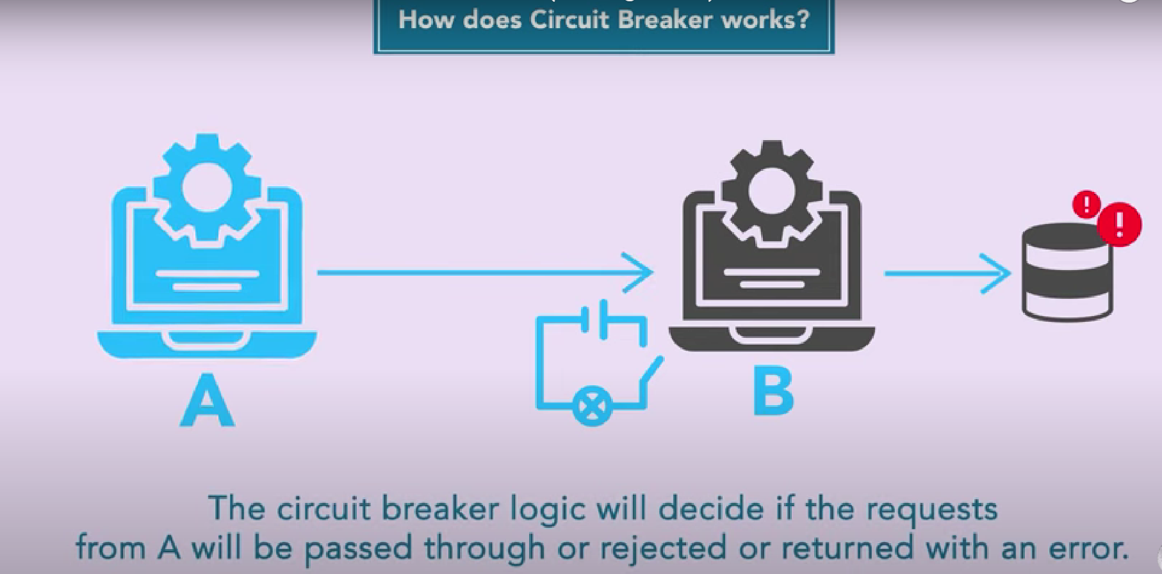  
  A screen shot of a phone

  AI-generated content may be incorrect.  
  by default it will be in closed state  
    
  A close up of a sign

  AI-generated content may be incorrect.  
    
    
  A red circle with blue letters and a red circle with black text

  AI-generated content may be incorrect.  
  A close-up of a sign

  AI-generated content may be incorrect.  
  A red and blue line with a red circle and a red arrow

  AI-generated content may be incorrect.  
  A blue and red line with a red dot and a red arrow

  AI-generated content may be incorrect.  
    
    
  A diagram of a failure

  AI-generated content may be incorrect.

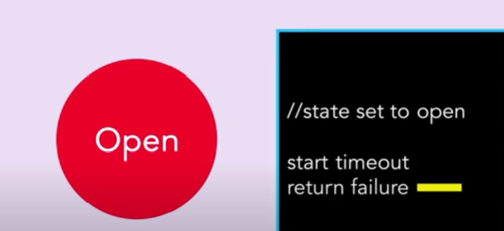  
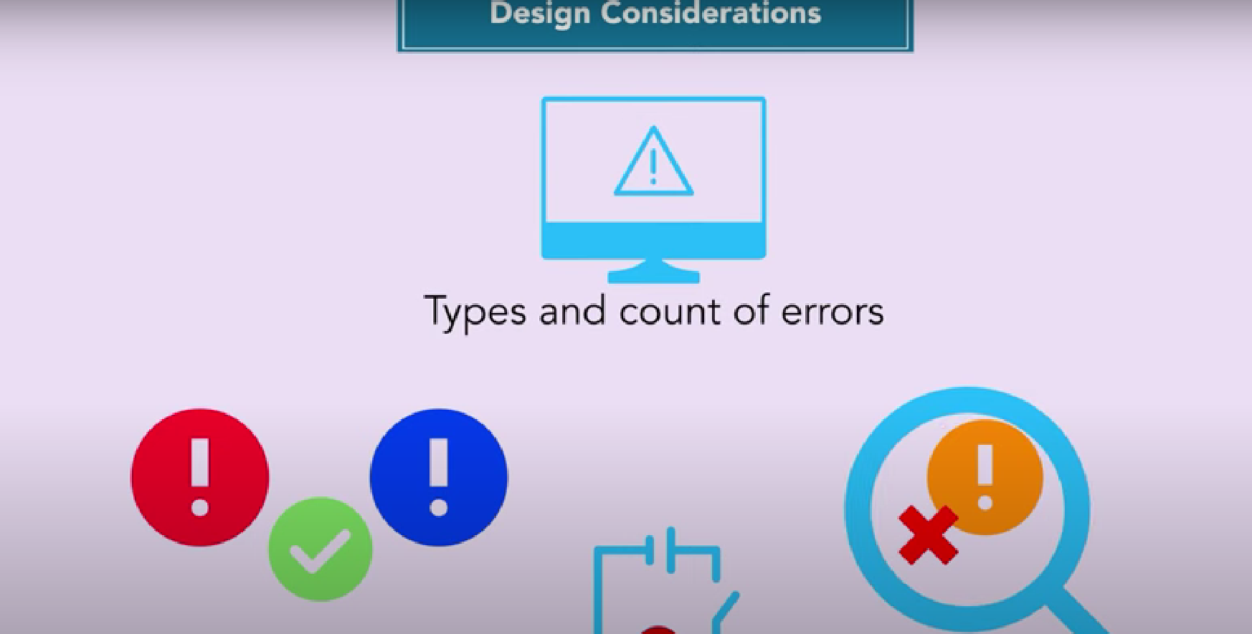  
  
Manual control for states  
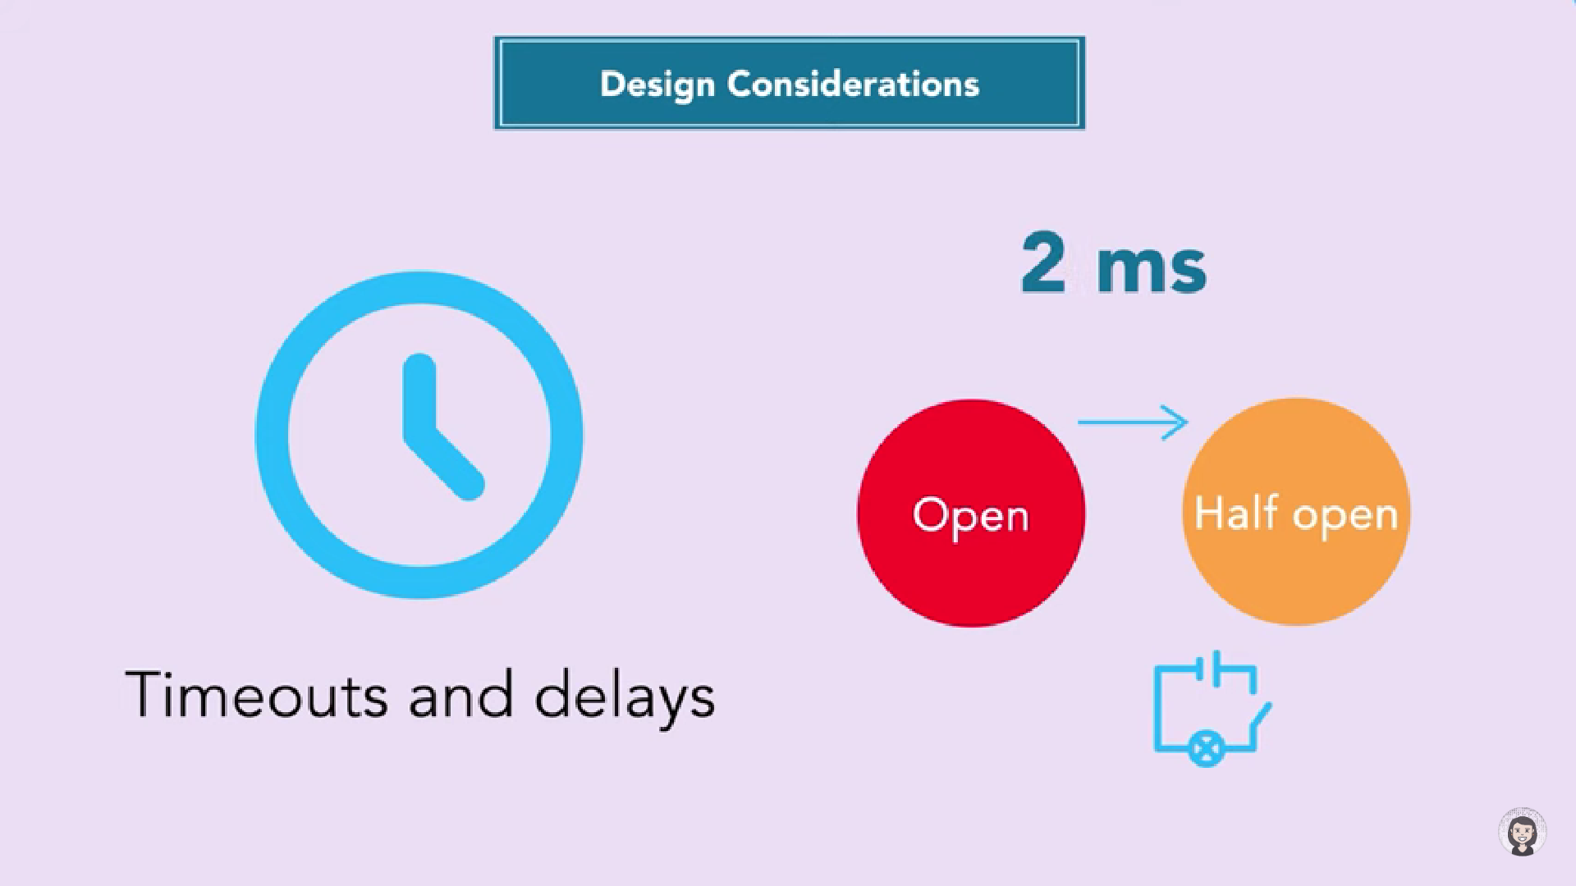  
  
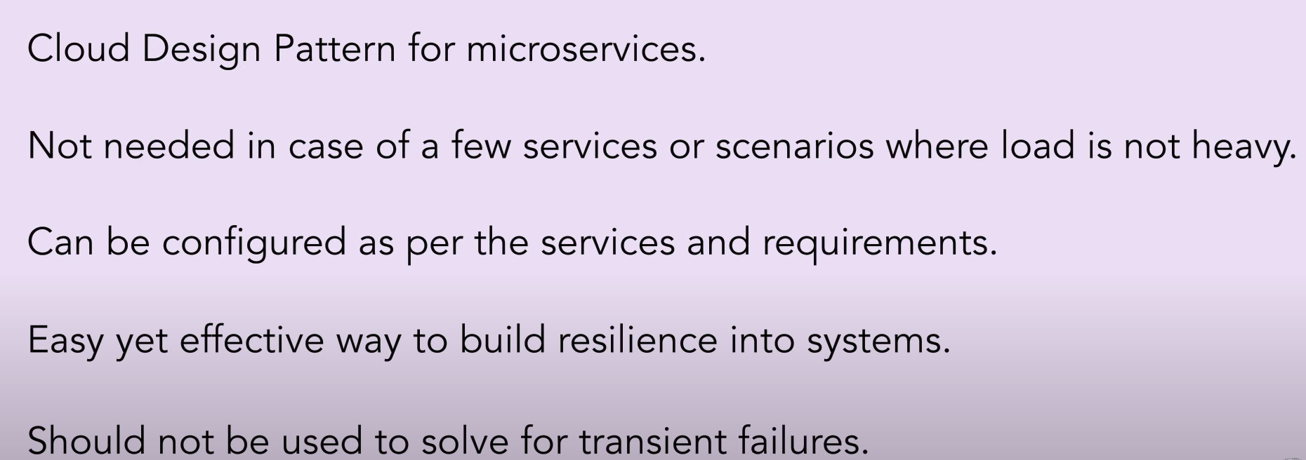  
  
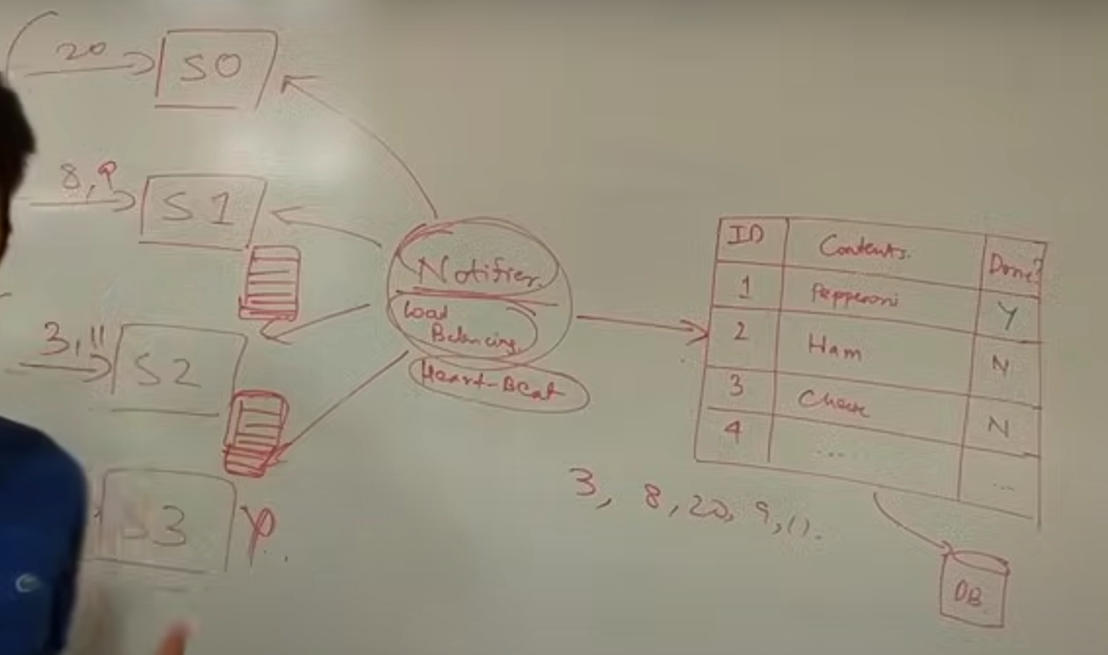  
  
  
  
**Marker Interface**

To make a class serializable, it must implement the java.io.Serializable interface. This interface is a marker interface, meaning it doesn't contain any methods. It signals to the Java runtime that objects of this class can be serialized.  
  
A marker interface in Java is an interface that does not declare any methods or fields. It serves as a tag or marker to classes that implement it, providing metadata about the class to the Java Virtual Machine (JVM) or other frameworks. This metadata can be used to trigger specific actions or behaviors at runtime. Common examples of marker interfaces in Java include Serializable, Cloneable, and Remote.

Marker interfaces inform the JVM or external libraries to handle the marked classes differently. For example, Serializable indicates that objects of the class can be serialized, while Cloneable suggests that objects can be cloned. The instanceof operator can be used to check if a class implements a specific marker interface, allowing for conditional logic based on the presence of the marker.

While marker interfaces are still used, they are sometimes considered a code smell because they blur the lines of what an interface represents, as they do not define any behavior. Newer development often favors annotations for similar purposes, as annotations offer greater flexibility. However, marker interfaces still provide compile-time type safety and integrate with the type system, which annotations cannot fully replace. Removing a marker interface from a class can break binary compatibility, so they should be used carefully.

**ObjectMapper**  
ObjectMapper, part of the Jackson library in Java, facilitates conversion between Java objects and JSON data. It's a crucial tool for serializing Java objects into JSON format and deserializing JSON back into Java objects. This process is essential for data exchange in web applications and APIs.

The ObjectMapper class provides methods for reading JSON from strings, streams, or files and converting it into Java objects. Conversely, it can transform Java objects into JSON strings. It handles various data types, including primitive types, collections, and nested objects.

Here's a basic example demonstrating how to use ObjectMapper for converting a Java object to JSON and vice versa:

Java

import com.fasterxml.jackson.databind.ObjectMapper;  
import java.io.IOException;  
  
class Person {  
 private String name;  
 private int age;  
 *// Getters and setters*  
 public String getName() {  
 return name;  
 }  
 public void setName(String name) {  
 this.name = name;  
 }  
 public int getAge() {  
 return age;  
 }  
 public void setAge(int age) {  
 this.age = age;  
 }  
}  
  
public class Main {  
 public static void main(String[] args) throws IOException {  
 ObjectMapper objectMapper = new ObjectMapper();  
  
 *// Java object to JSON*  
 Person person = new Person();  
 person.setName("John Doe");  
 person.setAge(30);  
 String jsonString = objectMapper.writeValueAsString(person);  
 System.out.println("JSON: " + jsonString);  
  
 *// JSON to Java object*  
 String json = "{ \"name\": \"Jane Doe\", \"age\": 25 }";  
 Person person2 = objectMapper.readValue(json, Person.class);  
 System.out.println("Name: " + person2.getName() + ", Age: " + person2.getAge());  
 }  
}

ObjectMapper offers customization options through annotations and configurations. These enable fine-tuning of the serialization and deserialization processes, such as handling date formats or ignoring specific fields.